Citation:

Are the results of this diagnostic study valid?
- Was there a clearly defined, focused research question? What was the study question?
- Was the index test described in sufficient detail to permit its replication?
- Was the presence or absence of the target condition confirmed with a validated, appropriate “gold” or reference standard? In other words, is the reference standard likely to correctly classify the target condition? Was the reference standard described in sufficient detail to permit its replication?
- Was the diagnostic test evaluated in an appropriate spectrum of patients? Was the spectrum of patients representative of the patients who will receive the test in practice? Or was it evaluated among patients with confirmed/severe disease and compared against healthy volunteers (case-control approach)?
- Did the whole sample or a random selection of the sample, receive verification using the reference standard test?
- Was the reference standard applied to all patients, regardless of the index test result? Did the results of the test being evaluated influence the decision to perform the reference standard?
- Was the reference standard independent of the index test (i.e. the index test did not form part of the reference standard)?
- Were the index test results interpreted without knowledge of (i.e. blinded) the results of the reference standard?
- Were the reference standard results interpreted without knowledge of (i.e. blinded) the results of the index test?
- Were uninterpretable/indeterminate test results accounted for and reported?
- Were withdrawals from the study accounted for?

Any other potential biases in this study?
What are the results?

SAMPLE CALCULATIONS:
 |  | Target Disorder  (iron deficiency anaemia) |  | Totals
 |  | Present | Absent
Diagnostic  Test Result | Positive  (<65 mmol/L) | 731 a | b 270 | a+b 1001
(serum ferritin) | Negative  (>65 mmol/L) | 78 c | d 1500 | c+d 1578
 | Totals | 809 a+c | b+d 1770 | a+b+c+d 2579
Sensitivity = a/(a+c) = 731/809 = 90%
Specificity = d/(b+d) = 1500/1770 = 85%
Positive Predictive Value = a/(a+b) = 731/1001 = 73%
Negative Predictive Value = d/(c+d) = 1500/1578 = 95%

YOUR CALCULATIONS:
 |  | Target Disorder |  | Totals
 |  | Present | Absent
Diagnostic  Test Result | Positive | a | b | a+b
 | Negative | c | d | c+d
 | Totals | a+c | b+d | a+b+c+d

Sensitivity = a/(a+c) =
Specificity = d/(b+d) =
Positive Predictive Value = a/(a+b) =
Negative Predictive Value = d/(c+d) =
Can you apply the results to patient care?
1. Is the diagnostic test available, affordable, and feasible in your setting?

2. Will the results be applicable to the patients in your setting? Is your patient so different from those in the study that its results can’t help you?

3. Can you generate a clinically sensible estimate of your patient’s pre-test probability (from practice data, from personal experience, from the report itself, or from clinical speculation)

4. Will the resulting post-test probabilities change your management strategy and help your patient? (Could it move you across a test-treatment threshold?)

5. Would the consequences of the test help your patient? (Will patients be better off as a result of the test?)

In summary:
What are the major strengths of this study?

What are the major limitations of this study?

Are there any major ethical concerns with this study?

APPENDIX:

Likelihood Ratio Nomogram
The Likelihood Ratio (LR) is the likelihood that a given test result would be expected in a patient with the target disorder compared to the likelihood that that same result would be expected in a patient without the target disorder. The LR is used to assess how good a diagnostic test is and to help in selecting an appropriate diagnostic test(s) or sequence of tests. They have advantages over sensitivity and specificity because they are less likely to change with the prevalence of the disorder, they can be calculated for several levels of the symptom/sign or test, they can be used to combine the results of multiple diagnostic test and the can be used to calculate post-test probability for a target disorder.
Formula for computing post-test probability, given pre-test probability and LR:
Post-test odds = pre-test odds X LR
Pre-test odds = pre-test probability / (1-pre-test probability)
Post-test probability = post-test odds / (post test odds+1)

To make it easier to move between odds and probability, the LR nomogram below can be used:
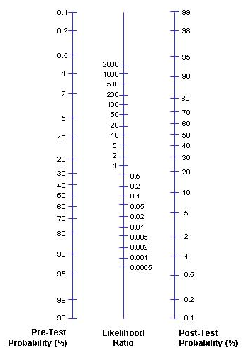
A LR greater than 1 produces a post-test probability which is higher than the pre-test probability. An LR less than 1 produces a post-test probability which is lower than the pre-test probability. When the pre-test probability lies between 30 and 70 per cent, test results with a very high LR (say, above 10) rule in disease. An LR below 1 produces a post-test probability less than the pre-test probability. A very low LR (say, below 0.1) virtually rules out the chance that the patient has the disease.

